Creating EC2 with user data and making AMI

**User data script: -**

#!/bin/bash

sudo apt update -y

sudo apt install -y apache2

sudo apt-get update -y

sudo apt-get install -y PHP

sudo apt-get update -y

sudo apt-get install -y maven

sudo apt-get update -y

sudo apt-get install -y nginx

sudo apt-get update -y

sudo apt-get install -y openjdk-11-jre-headless

sudo apt-get update -y

sudo apt install net-tools

sudo systemctl start apache2

sudo systemctl start nginx

User data of main instance 🡪

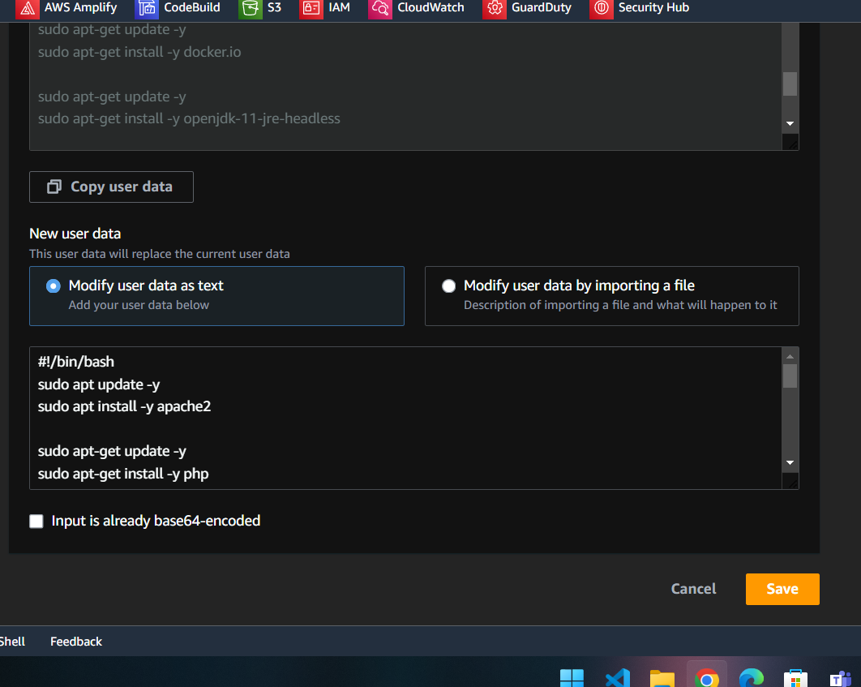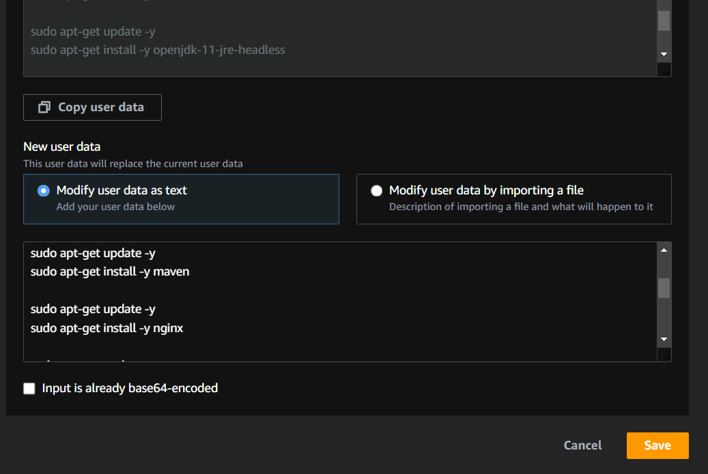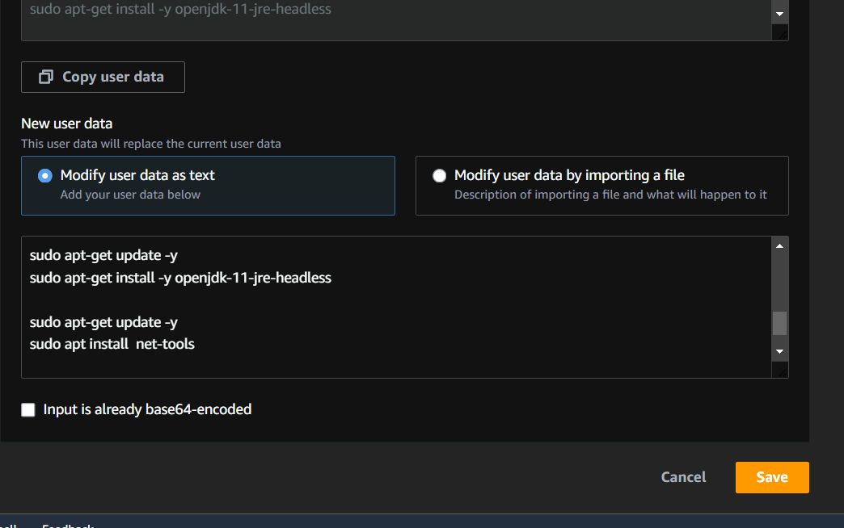

now, check in the main ec2 instance that everything is installed successfully

**Commands to check:**

|  |  |
| --- | --- |
| for maven | mvn -v |
| for apache2 | sudo systemctl status apache2 |
| for nginx | sudo systemctl status apache2 |
| for java | java -version |
| for net-tools | netstat –version |
| for php | php -v |

Now let's create AMI:

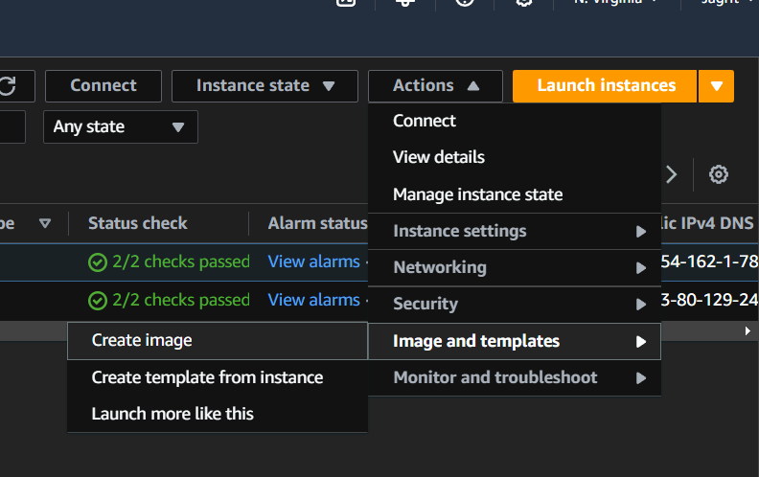

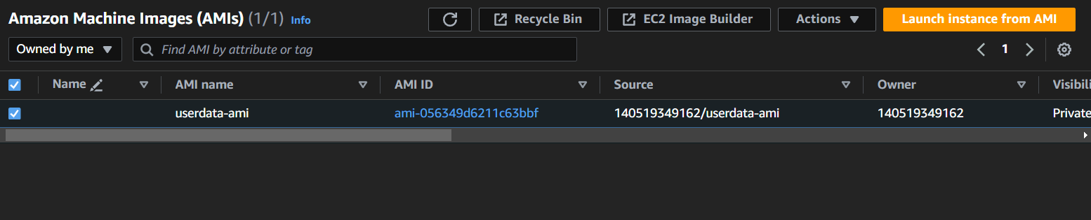

Now launching that AMI:



Now testing the softwares:

